**Physics 30 – Lesson 22**

**Generator Effect – Electromagnetic Induction**

/ 65

1)

d)

N

S

(–)

(+)

N

N

a)

e–

N

N

S

(+)

(–)

S

e–

/12

N

S

v

e–

(A) (+)

(–) (B)

e)

S

N

(–)

(+)

S

b)

e–

N

S

v

f)

No current, v is parallel to B

S

N

(+)

(–)

N

c)

e–

2)

A. Oersted’s hand rule – straight conductor

* Thumb – direction of current
* Fingers wrap around the conductor in the direction of the magnetic field

B. solenoid hand rule

* Fingers point in direction of current around the coil
* Thumb – direction of the magnetic field through the center of the coil

/3

C. flat hand rule – motor/generator

* Fingers point in direction of the external magnetic field
* Thumb – input (for motors-current, for generators-motion of conductor)
* Palm – output (for motors-force, for generators-direction of induced current)

3)



/4

4) Kinetic energy of conductor becomes electric energy inside the conductor.

/2

5)

**–**

**–**

**–**

**N**

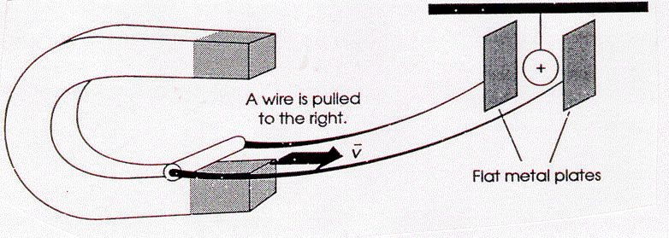

**+**

**+**

**+**





/4



**S**

Based on the movement of (+) ball the right-hand plate is negative. therefore, electrons flow toward the right plate and away from the left plate. Using the left hand rule, the palm points in the direction of the electron flow and the thumb points in the direction of motion of the wire. The result is that the fingers point down the page ­ i.e. the **magnetic field points down**. The top pole of the magnet is a north pole.

6)

Using the left hand rule, the fingers (B) point into the page, the thumb (v) points west and the palm indicates electron flow to the north. The **north tip of the wing becomes negatively charged**.





x x x x

x x x x

v

(–)

(+)





7)





8)



/2

9)



/6

10)



/6

11)



/6

12)



/6

13)



/5